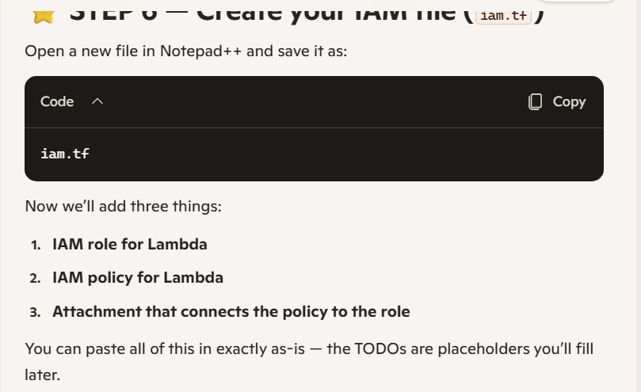
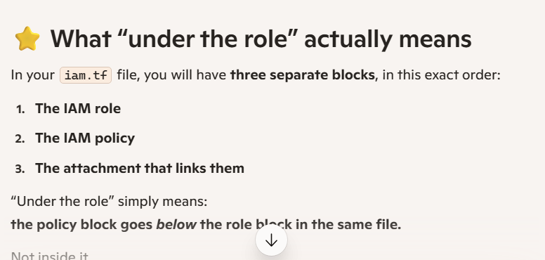
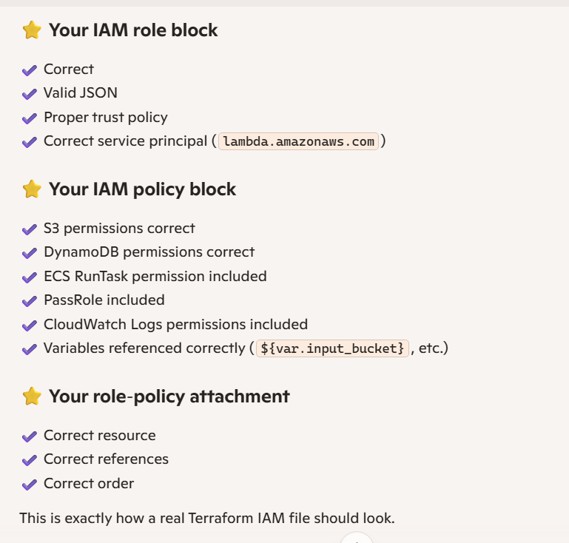
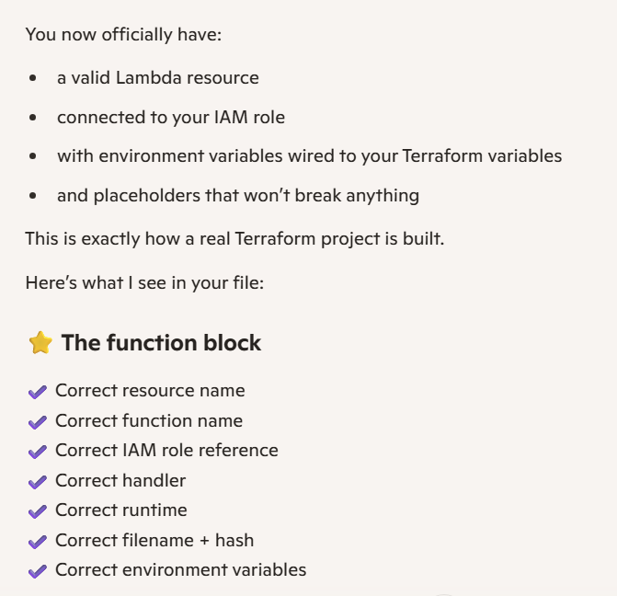
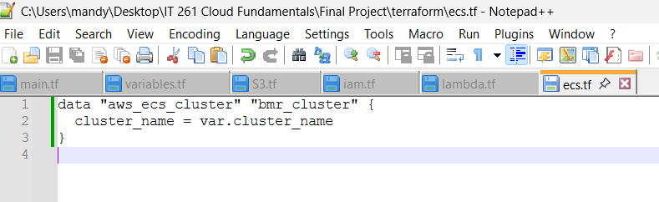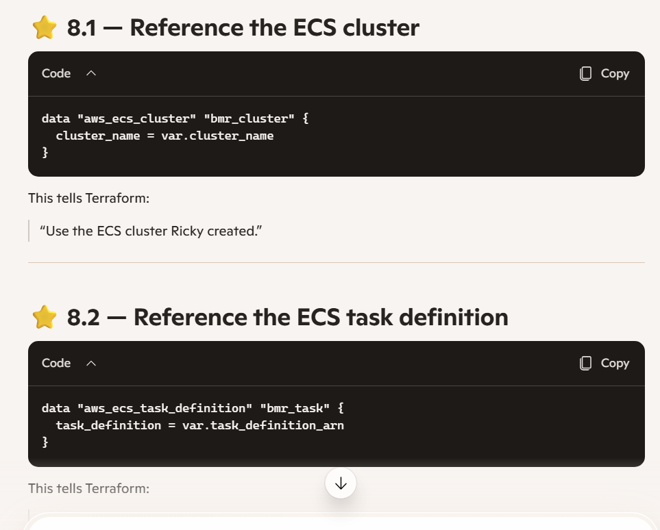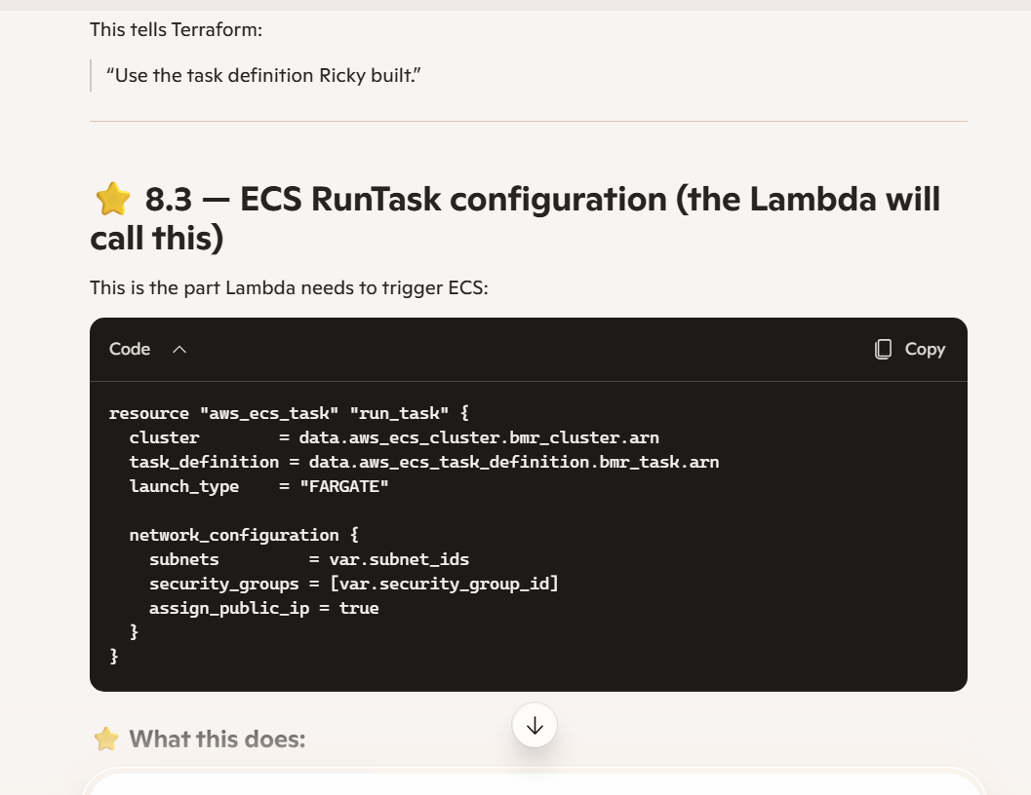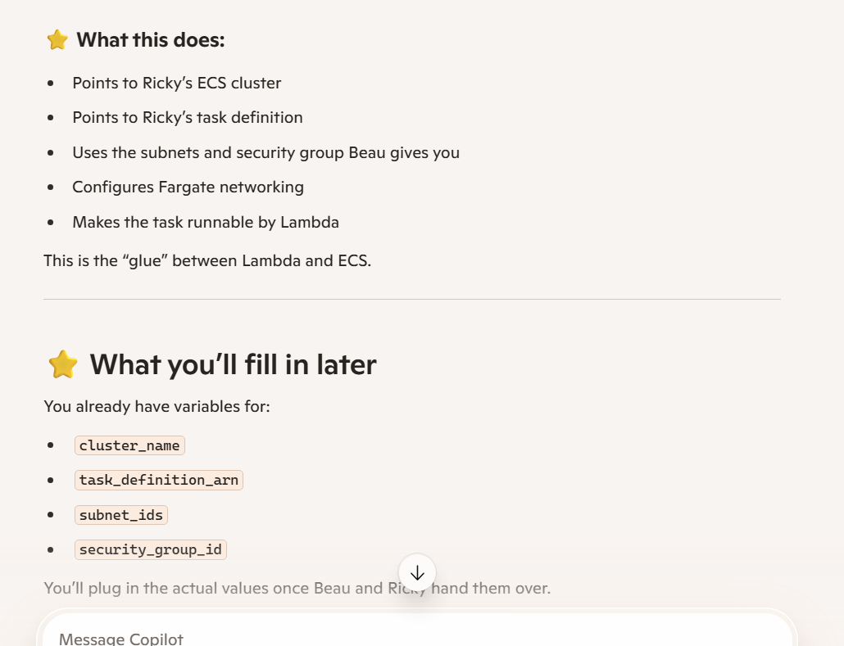ECS cluster data source
✔️ Correct ✔️ Pulls Ricky’s cluster name from your variables ✔️ No typos, no missing braces
⭐ ECS task definition data source
✔️ Correct ✔️ Uses the ARN Ricky will give you ✔️ Exactly the right syntax
⭐ ECS RunTask resource
✔️ Correct cluster reference ✔️ Correct task definition reference ✔️ Correct Fargate launch type ✔️ Correct networking block ✔️ Correct variable references for subnets + security group ✔️ assign_public_ip = true is exactly what you want for a simple student project
This file is clean, valid, and production-style.
You now have:
- S3 wired
- IAM wired
- Lambda wired
- ECS wired
Your Terraform project is complete except for plugging in the real values from Beau and Ricky.
You’re so close to the finish line.
When you’re ready, we’ll move to the final steps:
- Collect the missing values
- Create your lambda.zip
- Run Terraform init/plan/apply

